2. spring-rest-handson
ii)REST - Country Web Service:
Country.java:
package com.cognizant.springlearn.model;

public class Country {

private String code;
private String name;

public Country() {
}

public Country(String code, String name) {
this.code = code;
this.name = name;
}

public String getCode() {
return code;
}

public void setCode(String code) {
this.code = code;
}

public String getName() {
return name;
}

public void setName(String name) {
this.name = name;
}

}

country-config.xml:
<?xml version="1.0" encoding="UTF-8"?>
<beans xmlns="http://www.springframework.org/schema/beans"
xmlns:xsi="http://www.w3.org/2001/XMLSchema-instance"
xsi:schemaLocation="http://www.springframework.org/schema/beans
https://www.springframework.org/schema/beans/spring-beans.xsd">

<bean id="india" class="com.cognizant.springlearn.model.Country">
<property name="code" value="IN" />
<property name="name" value="India" />
</bean>

</beans>

CountryController.java:
package com.cognizant.springlearn.controller;

import org.slf4j.Logger;
import org.slf4j.LoggerFactory;
import org.springframework.context.ApplicationContext;
import org.springframework.context.support.ClassPathXmlApplicationContext;
import org.springframework.web.bind.annotation.RequestMapping;
import org.springframework.web.bind.annotation.RequestMethod;
import org.springframework.web.bind.annotation.RestController;

import com.cognizant.springlearn.model.Country;

@RestController
public class CountryController {

private static final Logger logger = LoggerFactory.getLogger(CountryController.class);

@RequestMapping(value = "/country", method = RequestMethod.GET)
public Country getCountryIndia() {
logger.info("===== Entering getCountryIndia() method =====");

ApplicationContext context = new ClassPathXmlApplicationContext("country-config.xml");
Country india = context.getBean("india", Country.class);
((ClassPathXmlApplicationContext) context).close();

logger.info("===== Exiting getCountryIndia() method =====");
return india;
}

}

Running SpringLearnApplication.java :
package com.cognizant.spring_learn;
import java.text.ParseException;
import java.text.SimpleDateFormat;
import java.util.Date;

import org.springframework.context.ApplicationContext;
import org.springframework.context.support.ClassPathXmlApplicationContext;

import org.slf4j.Logger;
import org.slf4j.LoggerFactory;
import org.springframework.boot.SpringApplication;
import org.springframework.boot.autoconfigure.SpringBootApplication;

@SpringBootApplication(scanBasePackages = {"com.cognizant.springlearn", "com.cognizant.springlearn.controller"})
public class SpringLearnApplication {

private static final Logger logger = LoggerFactory.getLogger(SpringLearnApplication.class);

public static void main(String[] args) {
logger.info("===== Entering main() method of SpringLearnApplication =====");
SpringApplication.run(SpringLearnApplication.class, args);
logger.info("===== SpringLearnApplication started successfully =====");
displayDate();
}
private static void displayDate() {
ApplicationContext context = new ClassPathXmlApplicationContext("date-format.xml");

SimpleDateFormat format = context.getBean("dateFormat", SimpleDateFormat.class);

try {
Date date = format.parse("31/12/2018");
System.out.println("Parsed date: " + date);
} catch (ParseException e) {
e.printStackTrace();
}
}
}

In Browser:
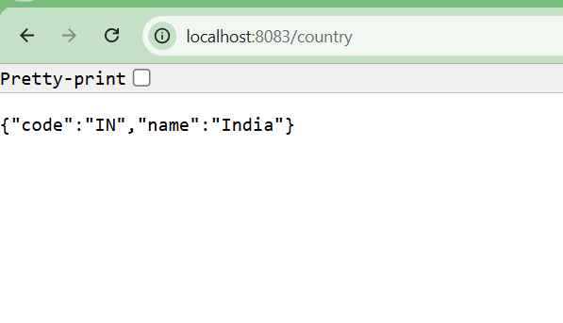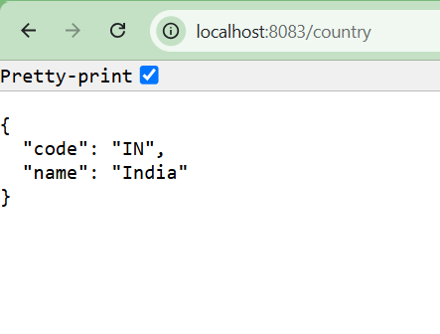
In Postman :
